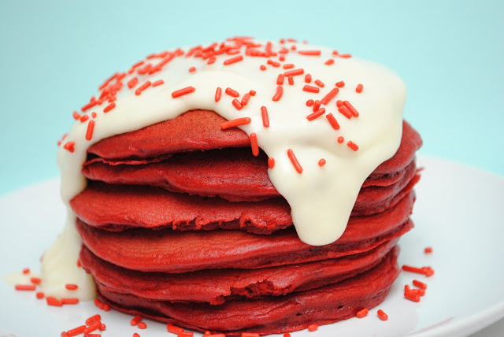
Red Velvet Pancakes & Cream Cheese Frosting
For the Pancakes:
- 1 1/4 cups all purpose flour
- 2 cups red velvet cake mix
- 1 Tablespoon sugar
- 3/4 teaspoon baking powder
- pinch of salt
- 2 large eggs
- 1 teaspoon vanilla extract
- 2 cups Milk
For the Cream Cheese Frosting:
- 4 oz. Cream Cheese
- 1/4 c. Butter, softened
- 2 ¼ cups powdered sugar
- 2-3 Tbsp. milk
- splash of vanilla, if desired
Instructions
For the Pancakes:
- Whisk together all ingredients and 2 cups milk.
- Pour pancake batter 1/4 cup at a time onto a preheated (about 300º) and buttered griddle or skillet.
- When bubbles form on top, flip and cook for another minute or two on the other side.
For the Cream Cheese Frosting
- In a stand mixer, whisk together the cream cheese and butter until smooth.
- Add in powdered sugar and milk, alternately, 1 cup (sugar) and 1 Tbsp. (milk) at a time until you’ve reached your desired consistency and sweetness.

